**Stat 602 Class Project Kaggle Scores Log**

**Team Kaggle Name: K fold K times**

**Team Members:** Reid-Vincent Paris (Vinny),Subrata Pal, Amin Shirazi

**______________________________________________________________________________**

**Week 12 (April 12-16)**

**Team's Best Result/Public Score Thus Far: 0.59023**

**Date and Time: 4/16/2021**

**Team's CV Result for the Submission: 0.59023**

**Screenshot of the Team's Best Score of the Week (Include Team Ranking and Score)**

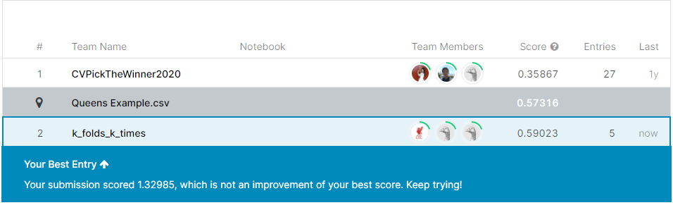

**Date and Time of the Screenshot: 4/16/2021, 01:15 PM**

**Number of Teams Registered at the Time of the Screenshot: 1**

**Week 13 (April 19-23)**

**Team's Best Result/Public Score Thus Far:** 0.43240

**Date and Time:**  April 23, 2:18

**Team's CV Result for the Submission:** 0.43240

**Screenshot of the Team's Best Score of the Week (Include Team Ranking and Score)**

**Date and Time of the Screenshot: April 23, 2:20**

**Number of Teams Registered at the Time of the Screenshot: 1**

**Week 14 (April 26-30)**

**Team's Best Result/Public Score Thus Far: ______________________________**

**Date and Time: ______________________________**

**Team's CV Result for the Submission: ______________________________**

**Screenshot of the Team's Best Score of the Week (Include Team Ranking and Score)**

**Date and Time of the Screenshot: ___________________**

**Number of Teams Registered at the Time of the Screenshot: ___________________**

**Week 15 (May 3-7) (Finals Week)**

**Team's Best Result/Public Score Thus Far: ______________________________**

**Date and Time: ______________________________**

**Team's CV Result for the Submission: ______________________________**

**Screenshot of the Team's Best Score of the Week (Include Team Ranking and Score)**

**Date and Time of the Screenshot: ___________________**

**Number of Teams Registered at the Time of the Screenshot: ___________________**